[Date]
Martina mallia
WLV NUMBER: 2582991
STC Higher Education, Malta
Patient Medication Record Tracking
Full Stack Development
Contents
No table of contents entries found.

No table of figures entries found.
No table of figures entries found.

Introduction
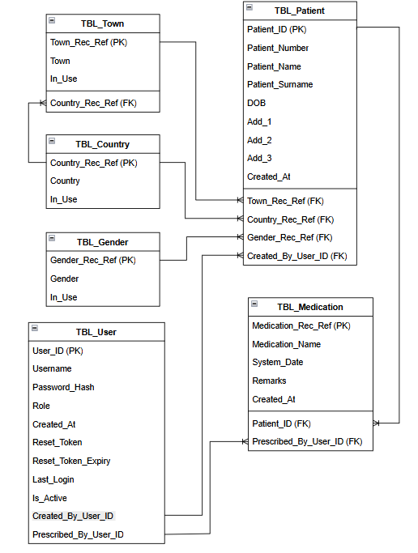

There are no sources in the current document.

